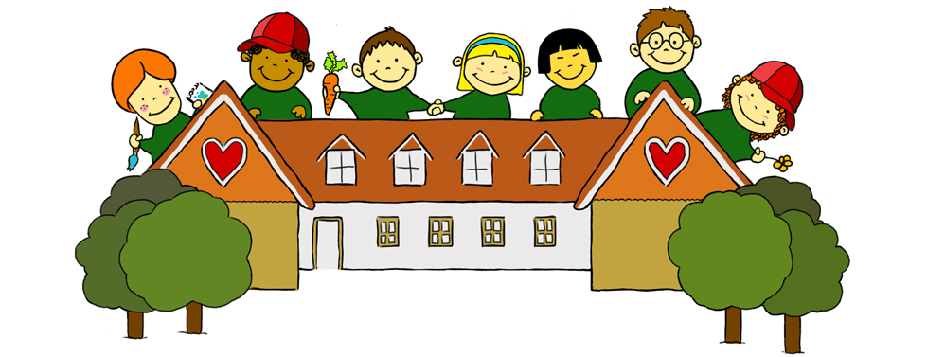

Health & Safety Policy

Accidents, incidents and emergency

The safety of your child is paramount and Language Garden will take every measure they can to prevent accidents, injuries or incidents.

Our premises have been very carefully laid out with young children in mind. We also regularly review, update and practice safety routines.

We hold current paediatric first aid certificates, which are accessible for parents to see in our Language Garden folder and are renewable every 3 years.

We hold written permission from parents to seek emergency treatment for their child if needed.

We keep a clearly labelled first aid bag with the appropriate contents in the office/store room, which are checked, updated and reviewed on a regular basis. Parent and emergency contact details are inside the first aid bag and updated frequently. On our walks and outings, we always take the first aid bag with us.

If there is an accident:
- We will comfort and reassure the injured child while making sure that the other children in our care are safe. This may mean sitting them where they can be seen.
- We will assess the extent of their injuries and carry out any first aid procedures that are necessary and we have been trained to do.
- If necessary, we will call for medical support/ambulance.
- If we have to accompany or take a child to hospital, we will either take the other children with us, or call the emergency back-up cover. This will be another known teacher or responsible adult (see list below).
If there is an accident or emergency, our emergency back-up cover may contact you and you will be expected to collect your child straight away.

If we manage to deal with the accident ourselves, then we will inform the parents immediately.

If we accompany or take a child to hospital, we will contact the parents and ask them to meet us at the hospital.

If we have an accident, we will get the nearest responsible adult to help, while our emergency back-up people are being contacted.

If it were a minor injury e.g. scraped knee, then we would inform the parent upon collection and ask them to sign the accident and incident book.

We will do our best at all times to make sure the children in our care are safe, reassured and kept calm.

All accidents and incidents will be recorded in the accident and incident book and signed by the teacher. Parents will be shown the details and asked to sign and date the relevant page when they collect their child.

Emergency Back-up Cover:

Back-up teachers: Verena Benz, Daniela Kohler
Known responsible adult: Anja Ashton, Daniela Kohler
Emergency helper: Next door neighbour Melanie Cutress (Falmer Village Hall committee member and our main contact)

Illness & medication
Language Garden cannot undertake the care of a sick child. In cases of mild illness, it is solely at the discretion of Language Garden if they allow the child to attend. In cases where medication is required, written permission must be given by the parent for each day on which medication is required. Language Garden must not allow any child suffering from a notifiable infectious disease on its premises because of the risk of infecting other children. Parents must inform Language Garden of any symptoms of ill health shown by the child. If the child becomes ill whilst at Language Garden, the parent/guardian will be contacted and asked to take the child home.
Language Garden will do their best to support individual children with medical needs. We require prior written consent and written instructions from the parents/guardians each and every time before we can administer any medication to their children. This must include the child’s name, exact dosage to be given, the time it is to be given and the number of times per day (the teachers will give you a copy of our ‘medicine administration consent form’ to complete and sign).
Parents must provide all medications needed by their children.

All medicines must be in their original containers with pharmacist or manufacturer's label, child's name, dosage instructions, current date and name of the medication clearly written.

If a child requires medication such as an asthma inhaler on a regular basis, the parent must leave one at Language Garden whenever their child is attending.
We store all medications in their original containers, inaccessible to children.
We keep written records of all medications administered to children. Each entry is signed by the person who gives the medication and by the parents before taking their children home.

We will not administer medicine unless it has been prescribed for the child by a doctor, dentist, nurse or pharmacist. We cannot administer any medication that your child has not taken previously in case it causes an allergic reaction.

Non-prescription medicine e.g. pain relief or teething gel may be given but only if there is a health reason to do so and only with prior written consent of the parent /guardian.

Some pain relief medicines such as Calpol can sometimes mask more serious medical conditions. It is therefore our policy that we place a limit of only administering one dose of such medicine to a child if needed (with prior written consent). If the child’s condition does not improve after this one dose, then it will need to be collected.

If a child has been given medicine at home in the morning before attending Language Garden, the parents/guardians must inform us before they arrive and provide the name of the medication, the dosage, the time it was given, and the reason for giving it.

We will keep records detailing medical requirements and administrations confidential and in a secure place.

If a parent wishes us to use any other lotions or creams on their child e.g. nappy cream, we will ask them to specify this and giving us permission in writing.

